1.2 Literature Review
This literature review synthesizes scholarship across four interconnected domains: the evolution of AI governance frameworks, geographic disparities in AI ethics discourse, computational methods for analyzing policy and academic texts, and limitations of current bibliometric approaches. Together, these bodies of work establish both the significance of geographically informed AI governance research and the methodological gap this study seeks to address.

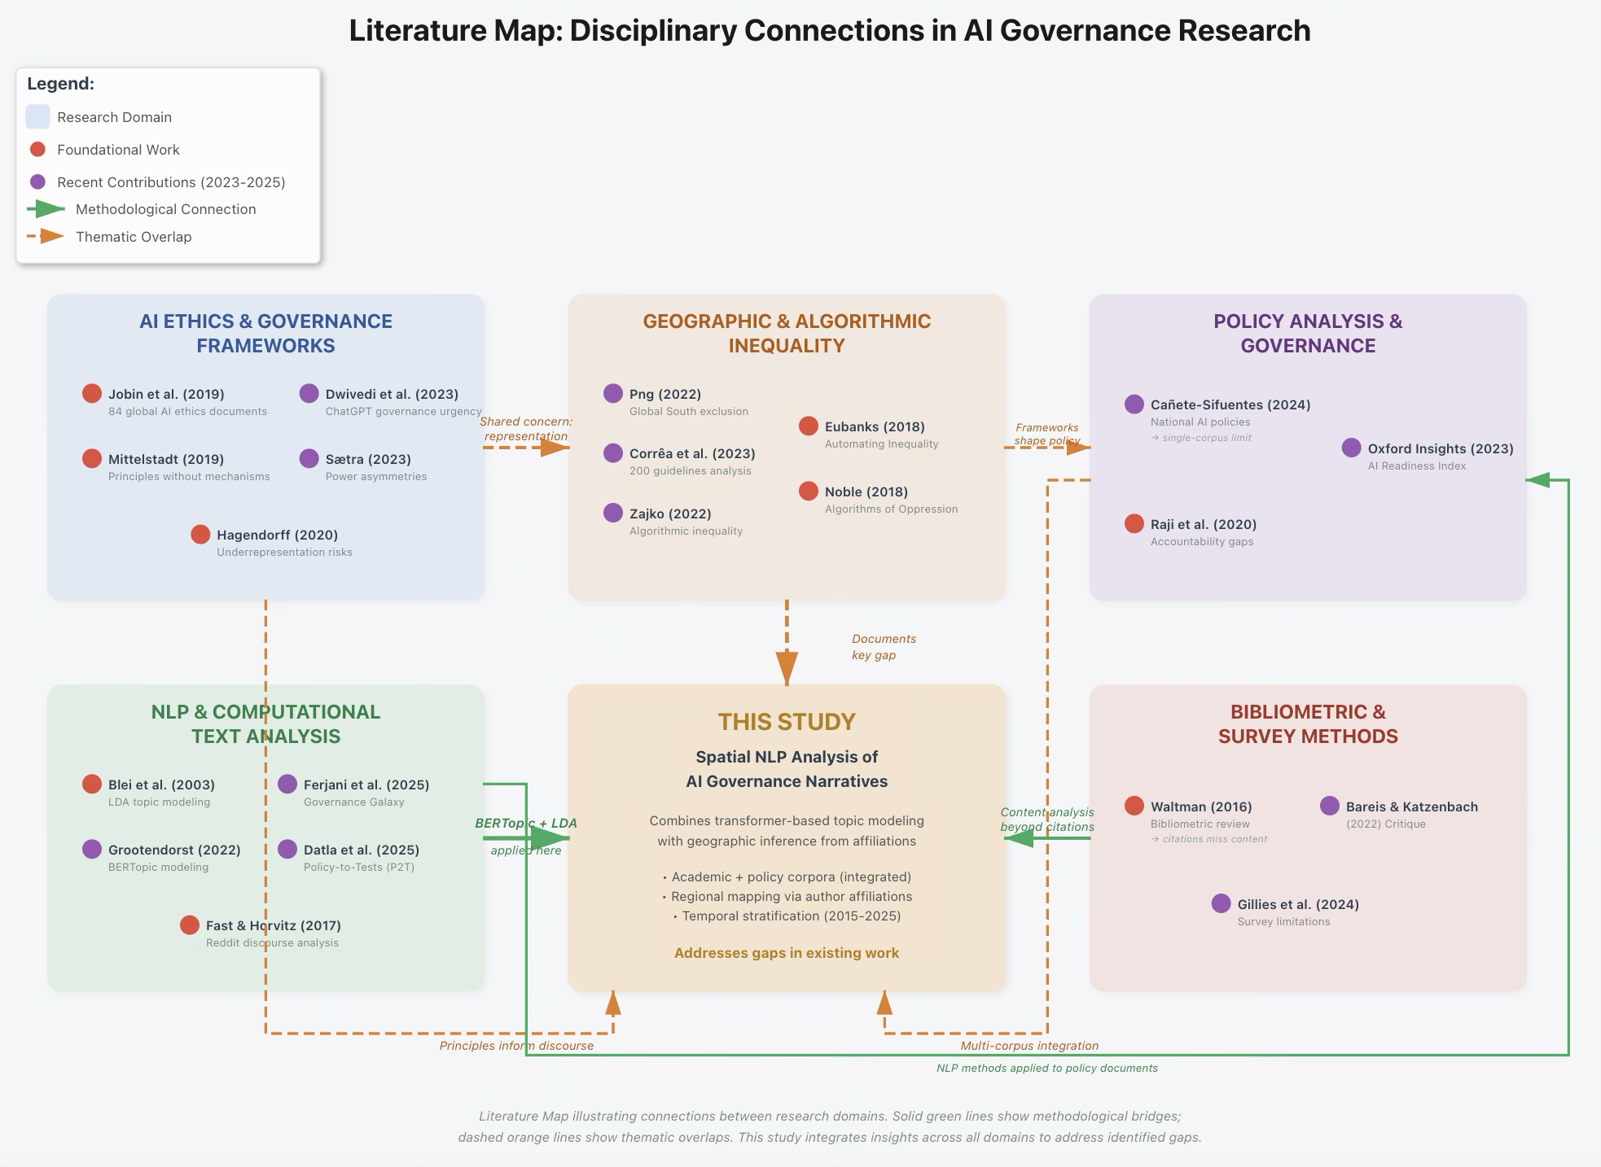

1.2.1 The Emergence and Evolution of AI Governance Frameworks
Over the past decade, AI governance has evolved from scattered technical guidelines to a structured field of institutional policy-making and ethical frameworks. Jobin et al. (2019) documented the proliferation of AI ethics principles across 84 documents from governmental, intergovernmental, and private sector sources, finding substantial convergence on core themes such as transparency, fairness, accountability, and privacy. This convergence suggested an emerging global consensus, yet Mittelstadt (2019) cautioned that principles alone do not constitute governance, noting that many frameworks lack enforcement mechanisms, clear assignments of responsibility, or concrete guidance for addressing competing values in practice.
The introduction of ChatGPT in November 2022 marked an inflection point, dramatically accelerating both public attention and regulatory urgency. Dwivedi et al. (2023) observed that generative AI systems intensified longstanding concerns about misinformation, job displacement, and algorithmic bias, while introducing new governance challenges around large-scale pre-training data, model opaqueness, and difficult-to-predict emergent capabilities. These developments have prompted governments worldwide to move from principle articulation to regulatory action, yet the speed and geographic unevenness of this transition raise questions about whose voices shape emerging regimes.
Critical assessments have highlighted persistent gaps in existing frameworks. Sætra (2020) argued that current AI governance approaches often treat ethical principles as universal abstractions, neglecting power asymmetries, cultural differences, and the political economy of AI development and deployment. This critique points toward the need for governance scholarship that explicitly examines whose perspectives are embedded in dominant frameworks and whose are marginalized, a question that spatial analysis of academic and policy discourse can help to answer.

1.2.2 Geographic Disparities in AI Ethics and Governance Discourse
Scholarship documenting geographic inequalities in AI governance participation has grown substantially in recent years. Png (2022) demonstrated that Global South perspectives remain severely underrepresented in major AI ethics forums and publications, noting that conferences and journals disproportionately publish work from North American and European institutions. This imbalance is not merely numerical; it reflects substantive differences in which AI risks are studied and prioritized. Corrêa et al. (2023) analyzed 200 AI governance guidelines globally, finding that documents from high-income countries tend to emphasize abstract principles such as fairness and transparency, while those from lower-income contexts more frequently foreground issues of digital infrastructure, data sovereignty, and economic dependency.
Critical scholarship on algorithmic inequality has documented how automation systems amplify existing social and economic disparities. Zajko (2022) showed that algorithmic systems systematically disadvantage marginalized communities through biased training data, under-resourced redress mechanisms, and design processes that exclude affected populations. Eubanks (2018) and Noble (2020) provided detailed case studies of how algorithmic decision-making in public benefits administration and search engines, respectively, reinforce racial and economic hierarchies in the United States. Hagendorff (2020) extended this critique to governance frameworks themselves, arguing that the underrepresentation of diverse perspectives in AI ethics guideline development risks producing principles that fail to address, or even actively reproduce, structural inequalities.
These findings establish that geographic and demographic representation in AI discourse is not a peripheral concern but a substantive governance issue. If dominant frameworks reflect the priorities and institutional contexts of a narrow set of regions, they may systematically overlook vulnerabilities and governance needs elsewhere. Spatial analysis of where and how AI risks are discussed thus becomes essential for assessing the inclusiveness of emerging governance regimes.

1.2.3 Computational Approaches to Policy and Academic Discourse Analysis
Advances in natural language processing have enabled large-scale analysis of policy and academic texts, revealing thematic patterns that would be difficult to discern through manual review. Topic modeling techniques have proven particularly valuable for identifying latent themes in unstructured corpora. Blei et al. (2003) introduced Latent Dirichlet Allocation (LDA), a generative probabilistic model that has become a foundational tool for discovering thematic structures in document collections. More recently, Grootendorst (2022) developed BERTopic, a transformer-based topic modeling approach that leverages pre-trained language models to produce more semantically coherent topics, particularly for shorter texts and domain-specific corpora.
Applications of NLP to governance and policy analysis have demonstrated the feasibility and value of computational text analysis for understanding regulatory discourse. Navaratna & Saxena (2025) applied topic modeling to national AI policy documents, finding significant variation in how countries frame AI priorities, though their study was limited to formal policy publications and did not integrate academic discourse or public consultation data. Ferjani et al. (2025) introduced the “Governance Galaxy” framework, a conceptual and computational approach for mapping relationships among AI governance principles, stakeholders, and regulatory mechanisms across documents, though their focus remained primarily at the document classification level rather than spatial or institutional attribution.
Methodological innovation in automated policy testing has also emerged. Datla et al. (2025) proposed the Policy-to-Tests (P2T) framework, which translates written policy documents into executable test cases for AI systems, enabling automated compliance checking. While P2T focuses on operationalizing policy requirements rather than analyzing discourse patterns, it illustrates the broader trend toward computational methods for bridging regulatory intent and technical implementation.
Prior work on public discourse has largely focused on social media platforms. analyzed Reddit discussions about AI, identifying common concerns and misconceptions, but their study did not address geographic variation or integrate expert discourse from academic or policy channels. These platform-specific studies provide valuable insights into public sentiment but leave a gap in understanding how expert communities and formal governance processes articulate AI risks across regions.

1.2.4 Limitations of Current Bibliometric and Spatial Analyses
Bibliometric studies have long tracked the geographic distribution of scientific output, but traditional citation-based metrics tell us little about substantive content. Waltman (2016) reviewed bibliometric methods for mapping research landscapes, noting that while co-authorship and citation networks reveal collaboration patterns and influence, they do not capture thematic focus or the specific governance priorities articulated in research. Bareis & Katzenbach (2022) extended this critique to AI ethics scholarship specifically, arguing that bibliometric approaches often produce misleading pictures of the field by emphasizing highly cited papers from elite institutions while obscuring diverse or emerging perspectives.
Tahaei et al. (2024) identified additional methodological challenges in assessing AI governance discourse, critiquing survey-based approaches for their reliance on predefined categories and limited geographic reach. They argued that surveys often reflect researchers’ assumptions about which issues matter rather than capturing the full range of concerns articulated by diverse communities. This limitation suggests the need for more inductive, text-driven approaches that allow themes to emerge from the data rather than being imposed a priori.
Navaratna & Saxena (2025) acknowledged a significant limitation in their own work: their focus on a single corpus of policy documents precluded comparison between government, academic, and civil society perspectives, and their geographic analysis was restricted to national-level policy statements rather than the underlying research and consultation processes that shape those statements. This limitation underscores the need for integrated, multi-corpus analyses that trace governance narratives across institutional contexts.

1.2.5 Research Gap and Study Positioning
The reviewed literature establishes several key points. First, AI governance has evolved rapidly but with persistent questions about whose voices shape dominant frameworks. Second, geographic disparities in AI ethics participation and representation are well-documented but rarely quantified through systematic spatial analysis of discourse content. Third, computational text analysis methods are mature enough to support large-scale thematic mapping, yet few studies have applied these methods to combined academic and policy corpora with explicit attention to regional variation. Fourth, existing bibliometric and survey-based approaches have significant limitations for capturing substantive governance priorities and their geographic distribution.
This study addresses the gap at the intersection of these domains by combining transformer-based topic modeling (BERTopic) with geographic inference from author affiliations and institutional metadata to map how AI governance narratives are distributed across regions in both academic publications and policy consultation processes. Unlike prior work that analyzes single corpora or lacks spatial granularity, this project integrates academic and governance-linked texts, assigns them to regions based on author affiliation data, and examines temporal evolution across a stratified 2015–2025 window.
The approach directly supports the study's objectives. By identifying dominant risk and governance themes through unsupervised topic modeling (RO1), mapping their institutional and regional distribution (RO2), and contextualizing patterns against global AI capacity indicators (RO3), this work aims to provide evidence on which concerns and constituencies are foregrounded or neglected in the expert and policy discourse that shapes AI regulation. In doing so, it contributes both methodologically, by demonstrating a reproducible workflow for spatial NLP analysis of governance texts, and substantively, by illuminating geographic patterns that can inform more inclusive and context-sensitive AI governance.

REFERENCES

Bareis, J., & Katzenbach, C. (2022). Talking AI into Being: The Narratives and Imaginaries of National AI Strategies and Their Performative Politics. Science, Technology, & Human Values, 47(5), 855–881. https://doi.org/10.1177/01622439211030007
Blei, D. M., Ng, A. Y., & Jordan, M. I. (2003). Latent dirichlet allocation. Journal of Machine Learning Research, 3(Jan), 993–1022.
Corrêa, N. K., Galvão, C., Santos, J. W., Del Pino, C., Pinto, E. P., Barbosa, C., Massmann, D., Mambrini, R., Galvão, L., & Terem, E. (2023). Worldwide AI ethics: A review of 200 guidelines and recommendations for AI governance. Patterns, 4(10). https://www.cell.com/patterns/fulltext/S2666-3899(23)00241-6
Datla, G. V., Vurity, A., Dash, T., Ahmad, T., Adnan, M., & Rafi, S. (2025). Executable Governance for AI: Translating Policies into Rules Using LLMs (arXiv:2512.04408). arXiv. https://doi.org/10.48550/arXiv.2512.04408
Dwivedi, Y. K., Kshetri, N., Hughes, L., Slade, E. L., Jeyaraj, A., Kar, A. K., Baabdullah, A. M., Koohang, A., Raghavan, V., & Ahuja, M. (2023). Opinion Paper:“So what if ChatGPT wrote it?” Multidisciplinary perspectives on opportunities, challenges and implications of generative conversational AI for research, practice and policy. International Journal of Information Management, 71, 102642.
Eubanks, V. (2018). Automating inequality: How high-tech tools profile, police, and punish the poor. Macmillan+ ORM. https://books.google.com/books?hl=en&lr=&id=pn4pDwAAQBAJ&oi=fnd&pg=PT6&dq=Eubanks,+V.+(2018).+Automating+Inequality:+How+High-Tech+Tools+Profile,+Police,+and+Punish+the+Poor.+New+York:+St.+Martin%27s+Press.&ots=gF3KLjeuvd&sig=kS-OrPlaEG3ANrV835JcI-mnR_0
Ferjani, I., Alzahrani, F. A., & Bouzir, N. M. (2025). Navigating Responsible AI: A Systematic Review of Governance Mechanisms and Future Co-Governance Scenarios. Procedia Computer Science, 270, 4726–4735.
Grootendorst, M. (2022). BERTopic: Neural topic modeling with a class-based TF-IDF procedure (arXiv:2203.05794). arXiv. https://doi.org/10.48550/arXiv.2203.05794
Hagendorff, T. (2020). The Ethics of AI Ethics: An Evaluation of Guidelines. Minds and Machines, 30(1), 99–120. https://doi.org/10.1007/s11023-020-09517-8
Jobin, A., Ienca, M., & Vayena, E. (2019). The global landscape of AI ethics guidelines. Nature Machine Intelligence, 1(9), 389–399. https://doi.org/10.1038/s42256-019-0088-2
Mittelstadt, B. (2019). Principles alone cannot guarantee ethical AI. Nature Machine Intelligence, 1(11), 501–507.
Navaratna, A., & Saxena, D. (2025). National AI Policy: Keyword and Topic Modelling Analysis. 2025 IEEE Guwahati Subsection Conference (GCON), 1–5. https://ieeexplore.ieee.org/abstract/document/11173368/
Noble, S. U. (2020). Algorithms of Oppression: How Search Engines Reinforce Racism. New York University Press. https://doi.org/10.18574/nyu/9781479833641.001.0001
Png, M.-T. (2022). At the Tensions of South and North: Critical Roles of Global South Stakeholders in AI Governance. Proceedings of the 2022 ACM Conference on Fairness, Accountability, and Transparency, FAccT ’22, 1434–1445. https://doi.org/10.1145/3531146.3533200
Sætra, H. S. (2020). A shallow defence of a technocracy of artificial intelligence: Examining the political harms of algorithmic governance in the domain of government. Technology in Society, 62, 101283.
Tahaei, M., Wilkinson, D., Frik, A., Muller, M., Abu-Salma, R., & Wilcox, L. (2024). Surveys considered harmful? Reflecting on the use of surveys in AI research, development, and governance. Proceedings of the AAAI/ACM Conference on AI, Ethics, and Society, 7(1), 1416–1433. https://ojs.aaai.org/index.php/AIES/article/view/31734
Waltman, L. (2016). A review of the literature on citation impact indicators. Journal of Informetrics, 10(2), 365–391.
Zajko, M. (2022). Artificial intelligence, algorithms, and social inequality: Sociological contributions to contemporary debates. Sociology Compass, 16(3), e12962. https://doi.org/10.1111/soc4.12962

